**NEWS FROM UNITED FOR ALL AGES – NOVEMBER 2023**

**CONNECTING A WORLD FOR ALL AGES**

Post-pandemic, we are seeing a renaissance in action by and for all ages in the UK and across the world, as reflected in this newsletter. The global campaign to combat ageism’s drive to connect generations is among the latest initiatives that are pushing tackling ageism up policy and practice agendas. With so much hatred in our world, connecting generations has got to be a key part of a positive way forward. Age segregation doesn’t promote mutual understanding and awareness.

In the UK, United for All Ages’ consultancy service is working with several new projects co-locating care homes and nurseries as well as intergenerational housing schemes. And we are delighted to support the first Dementia Care awards with a special intergenerational category – see below. Let’s celebrate the best interaction out there.

**DEMENTIA CARE AWARDS TO RECOGNISE INTERGENERATIONAL ACTION**

[**Care Talk**](https://caretalk.us2.list-manage.com/track/click?u=f288725a5765f05b33dcf4338&id=9346f8894a&e=035636fec7) **has announced the launch of The Dementia Care Awards.**These new awards will celebrate excellence and innovation in dementia services, recognise the dedication of frontline care professionals and pay tribute to people living with dementia who make a real difference to the sector and their communities.

United for All Ages is supporting the awards and particularly encourages entries in the intergenerational category.

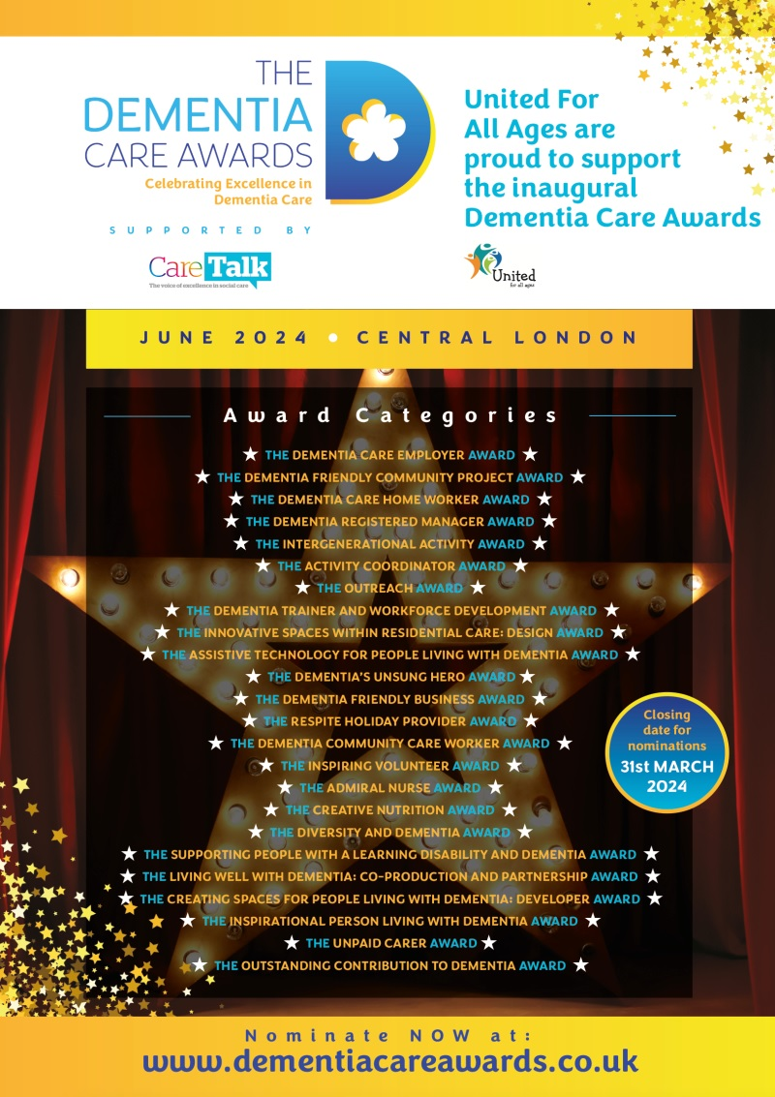

**ALL GO AT APPLES AND HONEY NIGHTINGALE**

The UK’s first care-home nursery, Apples and Honey Nightingale (AHN), opened its intergenerational community space recently. Everyone helped make it a success, from a four week old baby who was initiated into the baby and toddler session to the retired ballet professor in his 80s who travelled in by bus and train to lead a session, to the children who dropped in after school to chat and help complete jigsaw puzzles. The space is running every Monday with more opportunities involving local schools, faith groups and community services.

AHN’s Centre for Intergenerational Practice, Research and Development will launch on 30 November. They are building a strong national and international network and are welcoming new members. See <https://ciprdcouk.wordpress.com/>

Registration is also open for AHN’s next cohort of students for their NCFE accredited Level 3 qualifications in Intergenerational practice. The taught online courses begin on 4 January 2024. More information is available at [AHN Education and Training](https://ahneducation.org/)

The third NIghtingale Hammerson Care Home Research Forum meets on 29 November. Judith Ish-Horowicz will be speaking about developments in Intergenerational work, along with other speakers. Check it out at [Care Home Research Forum 2023 | Nightingale Hammerson](https://nightingalehammerson.org/events/chrf2023/)

**NEWS, RESOURCES AND EVENTS**

**Making an impact:** Ready Generations has just published its first annual impact report about its co-located nursery at Chester Belong Village. The report will be available at [Ready Generations – The authentic integration of early childhood services](https://readygenerations.co.uk/)

**Workplaces for all ages:** We are pleased to see that GrandNanny has extended its role as Grandworks to help match employers with skilled workers aged over 50. Find out more: <https://grandworks.co.uk/>

United for All Ages recently contributed to a debate about ‘managing a multigenerational workplace’ – see: <https://www.linkedin.com/events/managingamulti-generationalwork7104412297267142656/theater/>

**New reading:** Working Wise has just published this article on connecting the generations through work and through care: <https://www.workingwise.co.uk/getting-the-generations-together/>

**Shifting how we view ageing:** King’s College London has published a report based on its Policy Lab on Shifting How We View the Ageing Process that took place last autumn. They have been undertaking a range of follow up work and events this year and welcome further inputs. See the report: <https://www.kcl.ac.uk/policy-institute/assets/shifting-how-we-view-the-ageing-process.pdf>

**GWT membership scheme:** Generations Working Together have introduced a [new membership structure.](https://generationsworkingtogether.org/become-a-member) They have more categories of membership which are free – for example, if you’re a professional working in the Global South.  Some have reduced in price. Their global reach and network is growing. With the success of [IGWeek23](https://generationsworkingtogether.org/global-intergenerational-week)  and their online [International Certificate in Intergenerational Practice](https://generationsworkingtogether.org/training/international-certificate-in-intergenerational-practice-icip), GWT is dedicated to advancing intergenerational work and connecting people from around the world who want to make a positive impact.

Check out the new offer – and receive access to training at a discounted rate, online thematic networks and priority booking for events, resources, tools and publications, expert guidance and support as well as access to a growing international network.  Find out more here: <https://generationsworkingtogether.org/become-a-member>

**Regenerating outdated sheltered housing:**

|  |
| --- |
| A new All Party Parliamentary Group inquiry has been launched on the regeneration of outdated sheltered housing. It seeks to understand how best to regenerate the existing supply of outdated sheltered housing to meet the demands of the 21st century. This is also a chance to promote intergenerational housing in sheltered housing schemes.  **The deadline for submissions is Friday 23 February 2024. See:** [APPG Inquiry: Regeneration of Outdated Sheltered Housing - Sheltered housing - Housing for Older People - Housing - Topics - Resources - Housing LIN](https://www.housinglin.org.uk/Topics/browse/Housing/HousingforOlderPeople/ShelteredHousing/appg-inquiry-sheltered-housing-regen/) |

|  |
| --- |
|  |

**Homeshare webinar:** The latest Two Generations' homeshare webinar on Tuesday 7 November, will focus on how homeshare can help councils save money. It will be chaired by Luciana Berger, former Shadow Health Minister and now senior Adviser at iNHouse[**BOOK YOUR TICKET HERE**](https://d2hNlP04.na1.hubspotlinksfree.com/Ctc/GF+113/d2hNlP04/VVm_zv4djVQDW2D626y6rNMTkW2_PQhc54LxvrN7-7xy87j7nCW5BWSxg6lZ3mLW5J3bHR292PVCW84xLGk3kM7xTW4_hM5N7w3Hz7W3k0Ssw550sk2N8mm7XtRF2JVW3wPFzP5BkZsfW3xpKZK1cLCV3W57r-W419yS4wW7F6wMv5Pc5dBW1QvxKF5jXW80W6tpxk53RMTBKW2-24kG8Py-LDW1ZNZBv5dl6CwF6907q7GvGMW7cP2Mf6W68LtW55hnHH1tFPDqN28VmvVgxsCRW2Mtvtm4DkcLmW8231816XWV85W7xVfqm6m8q_1W5Zsm7l7gZXrvW3KTzq82kVFllW3fB4ZP2FD92NW617crq9jV4CgVVYSQ55GKbcXW8tN2t_3Clc70W2WZjm_99Q3RkVyf9lt4Xr7zWW4VKlC76lmjrzW3GkpjS6gqF-SVmX5gr6sxMpsW1Ry9Yj6YvDKsW558KJ53lHGPbW1LR0Ln2-Mdf0W7BdMZX45-dXPW5fMfYz7WJn2GW4G1fWx4Nzf0SW6ktgT_30rscZW1xyx5F4jTp9hW8T_Lsv6n8jQNN3fwMQG6rW4vW515TXb8QwRFhW7fXxCk6B9h7pN7VfytZbfKjqVmqlPJ2p36gJW6pjwH-2L0dsDW83MpDm4XYYgXW7C6KD54HgjmVW4sndhV1hJ8xpW96bZGY70b5hRf2HvRnM04)

Their previous seminar on how homeshare can promote healthy lives can still be viewed at [Two Generations Webinar: How Homeshare Helps Tackle Loneliness, Improves Health & Social Impact - YouTube](https://www.youtube.com/watch?v=-eu20UUvgR0)

**Thought for the month from ILC-UK:** The share of wealth held by under-40s has plummeted over the past decade – from £7.53 in every £100 to only £3.98

<https://ilcuk.org.uk/future-pensioner-poverty/>

|  |  |  |
| --- | --- | --- |
| |  |  | | --- | --- | | |  | | --- | | **New resource: Build #AWorld4AllAges by**Connecting Generations | | |

|  |  |
| --- | --- |
| |  | | --- | |  | |

|  |  |  |
| --- | --- | --- |
| |  |  | | --- | --- | | |  | | --- | | **Are you looking for a practical guide on how to plan and implement effective interventions for intergenerational contact?** [Connecting Generations](https://aworld4allages.us3.list-manage.com/track/click?u=c7943277461ee4157547221f2&id=e48ab6fd27&e=c50549a409) is a new guide from the Global Campaign to Combat Ageism! | | |

For more about the above and about United for All Ages and our work, please contact us.

All the best

Denise

Denise Burke

Director

United for All Ages

01206 824529

07889 778316

[www.unitedforallages.com](http://www.unitedforallages.com/) @united4allages