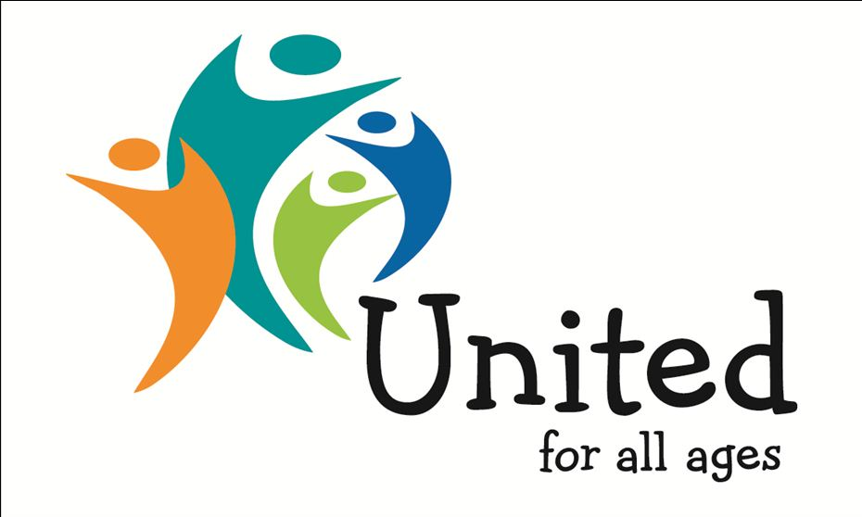

NEWS RELEASE
For immediate release: Monday 29 July 2019
#ALLAGESAUGUST BRINGS BRITAIN TOGETHER – WITH YOUNGER AND OLDER PEOPLE SHARING ACTIVITIES AND EXPERIENCES
Hundreds of events and activities across the UK in August will bring together younger and older people to share activities and experiences while tackling loneliness, isolation and ageism.
United for All Ages is celebrating and promoting this summer fun by designating August as #AllAgesAugust, a first for the growing intergenerational movement.
Britain is one of the most age segregated countries in the world, with increasing awareness of the social and economic problems that this lack of connection causes. Intergenerational interaction can improve care, housing and learning while addressing loneliness, ageism and division in our society.
All ages activities in August range from sports to arts, festivals to fetes, holidays to play days, conferences to museums and libraries, grandparents to grandchildren including:
- canoe tours on Bristol’s floating harbour to the Big Summer Social at Stratford Circus Arts Centre to Dance Umbrella’s Invisible Dancing in Woolwich

- an increasing number of families are taking multi-generational holidays at home and abroad this summer: https://www.bbc.co.uk/news/business-49125440#

- Playday 2019 with its theme, Play builds children, to science experiments for all ages in Yorkshire

- scores of intergenerational projects involving care homes and nurseries, sheltered housing schemes and out of school summer holiday clubs

- Salcombe Town Regatta and Sheringham Carnival to the Edinburgh Festival and Notting Hill Carnival

- the start of the 2019-20 football season to the 2019 Ashes cricket test series to Ride London Freecycle

- wide-ranging events organised by Royal Museums Greenwich, Culture Mile London, Wigan Libraries, North Yorkshire Libraries and many others

Stephen Burke, Director of United for All Ages, said: “#AllAgesAugust is all about bringing Britain together by bringing older and younger people together and sharing common interests and concerns. Hundreds of activities around the UK will enable people of all ages to have fun together and share experiences during the 31 days of August. These common bonds will also help tackle loneliness, isolation and ageism in Britain. Uniting generations will help bring Britain together.
“What are you doing in August? It’s still not too late for organisations to get involved in the first #AllAgesAugust. Join hundreds of others bringing older and younger people together to create stronger communities and a stronger Britain – and use hashtag #AllAgesAugust.”

NOTES TO EDITORS
More information is at www.unitedforallages.com/news or search twitter for #AllAgesAugust for events and activities
Kicking off the summer fun was a ‘picnic and party’ event in Norwich on Saturday 27 July to celebrate Norfolk Day @FriendInDeed
Media queries to Stephen Burke, Director, United for All Ages tel: 01692 650816 e: stephen.burke@unitedforallages.com t: @united4allages

